CONGESTION FORECASTING WORKFLOW

OBJECTIVES:
The objective of the Congestion Forecasting Workflow is to predict traffic congestion using historical and live traffic data. The system analyzes the data, forecasts the congestion level, generates alerts if required, and updates the traffic monitoring dashboard.

PURPOSE:
This module helps traffic authorities monitor road conditions, predict traffic congestion in advance, and improve traffic management by providing timely alerts and accurate traffic predictions.

WORKFLOW OVERVIEW:
STEP | DESCRIPTION
1. | Collect historical traffic data
2. | Receive live traffic data
3. | Clean and prepare the data
4. | Predict congestion level
5. | Generate alerts
6. | Update dashboard
7. | Store prediction results

Expected Input:
- Historical Traffic Data
- Live Traffic Data
- Vehicle Count
- Average Speed
- Timestamp
- Road ID

Expected Output:
- Congestion Level (Low/Medium/High)
- Traffic Alert
- Updated Dashboard, Prediction Record.

WORKFLOW:

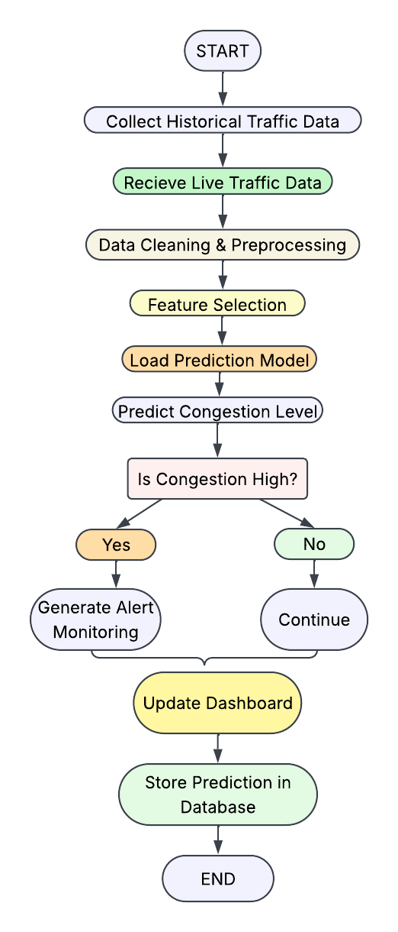

INPUT DATA SPECIFICATIONS:
INPUT | EXAMPLE | PURPOSE
Road ID | R001 | R001
Vehicle Count | 450 | Indicates traffic volume
Average Speed | 25 km/h | Indicates traffic movement
Date | 2026-08-13 | Historical reference
Time | 08:30 | Helps identify peak hours
Weather | Rainy | Optional Traffic factor

FORECASTING LOGIC:
const WEIGHTS = {
density: 0.6,
speed: 0.4
};
const THRESHOLDS = {
low: 0.4,
medium: 0.7
};
// Calculate congestion score
function calculateCongestionScore(vehicleCount, roadCapacity, averageSpeed, speedLimit) {
const density = Math.min(vehicleCount / roadCapacity, 1);
const speedFactor = Math.min(
Math.max(1 - averageSpeed / speedLimit, 0),
1
);
const score =
(density * WEIGHTS.density) +
(speedFactor * WEIGHTS.speed);
return Math.round(score * 100) / 100;
}
// Classify congestion level
function classifyCongestion(score) {
if (score < THRESHOLDS.low) {
return "LOW";
}
if (score < THRESHOLDS.medium) {
return "MEDIUM";
}

return "HIGH";
}
// Decide the action
function decideAction(level) {
if (level === "HIGH") {
return {
alert: true,
alternateRoute: true,
message: "Heavy congestion detected"
};
}
if (level === "MEDIUM") {
return {
alert: false,
alternateRoute: false,
message: "Moderate traffic - plan ahead"
};
}

return {
alert: false,
alternateRoute: false,
message: "Traffic flowing normally"
};
}
// Main congestion forecasting workflow
function forecastCongestion(input) {
const {
locationId,
vehicleCount,
roadCapacity,
averageSpeed,
speedLimit
} = input;
const score = calculateCongestionScore(
vehicleCount,
roadCapacity,
averageSpeed,
speedLimit
);
const level = classifyCongestion(score);
const action = decideAction(level);
return {
locationId: locationId,
congestionScore: score,
congestionLevel: level,
alert: action.alert,
alternateRoute: action.alternateRoute,
message: action.message
};
}
module.exports = {
calculateCongestionScore,
classifyCongestion,
decideAction,
forecastCongestion
};

averageSpeed,
speedLimit
} = input;
const score = calculateCongestionScore(
vehicleCount,
roadCapacity,
averageSpeed,
speedLimit
);
const level = classifyCongestion(score);
const action = decideAction(level);
return {
locationId: locationId,
congestionScore: score,
congestionLevel: level,
alert: action.alert,
alternateRoute: action.alternateRoute,
message: action.message
};
}
module.exports = {
calculateCongestionScore,
classifyCongestion,
decideAction,
forecastCongestion
};

CONGESTION CLASSIFICATION:

PURPOSE:
The purpose of congestion classification is to convert the calculated congestion score into a meaningful traffic condition: LOW, MEDIUM, or HIGH. This classification helps the system determine the appropriate action for the current traffic condition.

CLASSIFICATION RULES:
Congestion Score | Congestion Level | Meaning
< 0.4 | LOW | Traffic is flowing normally
0.4 – < 0.7 | MEDIUM | Moderate traffic; users should plan ahead
≥ 0.7 | HIGH | Heavy congestion detected

CLASSIFICATION PROCESS:
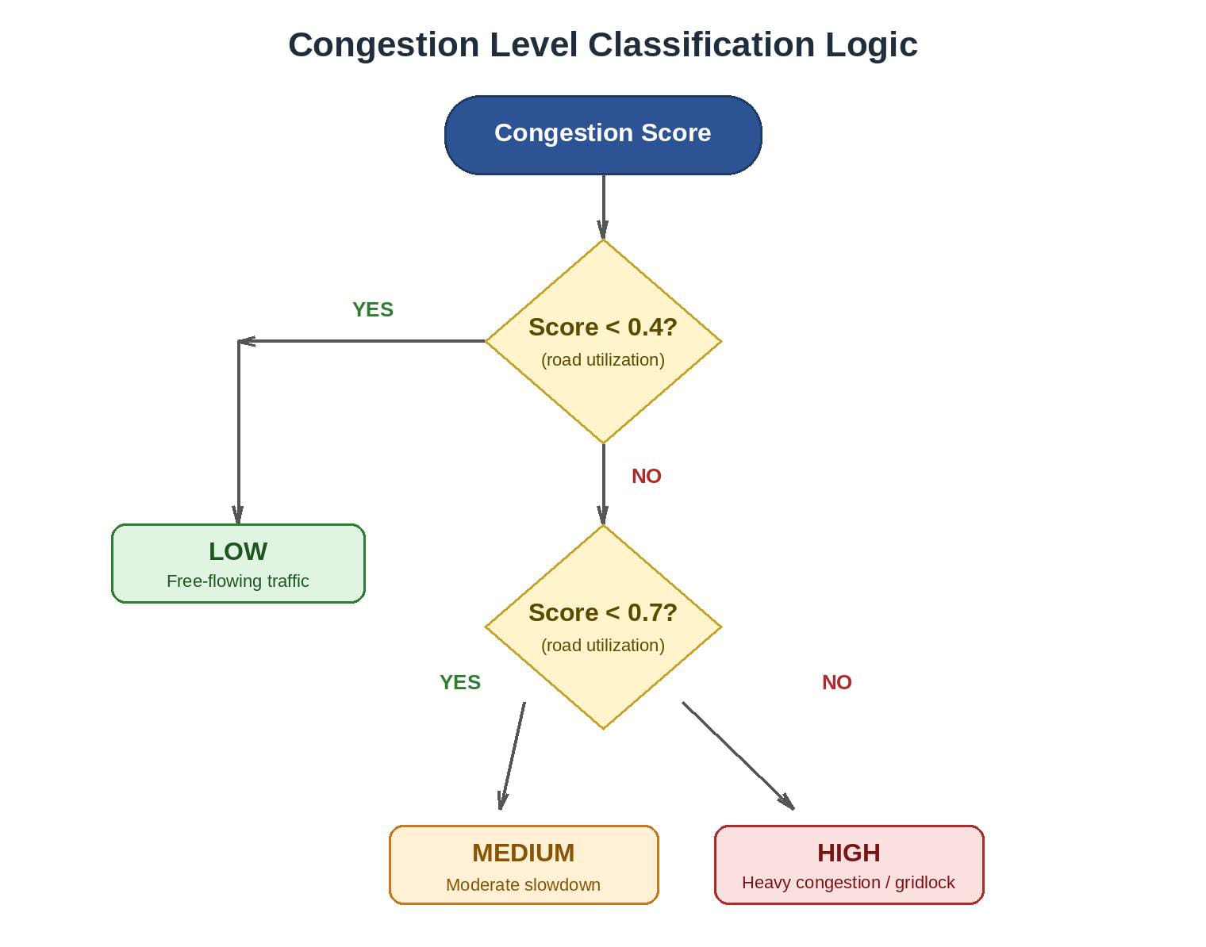

SYSTEM ACTION:
LEVEL | SYSTEM ACTION
LOW | Continue normal monitoring
MEDIUM | Display “Moderate traffic – plan ahead”
HIGH | Generate alert and suggest alternate route

EXAMPLE:
If the calculated congestion score is 0.75, the score is greater than or equal to 0.7. Therefore, the system classifies the traffic as HIGH and triggers an alert with an alternate-route recommendation.

ALERT &ACTION HANDLING:

PURPOSE:
The purpose of Alert and Action Handling is to determine the appropriate system response based on the predicted congestion level.

ACTION RULES:
CONGESTION LEVEL | ALERT | ALERT ROUTE | SYSTEM MESSAGE
LOW | NO | NO | Traffic flowing normally
MEDIUM | NO | NO | Moderate traffic – plan ahead
HIGH | YES | YES | Heavy congestion detected

PROCESS FLOW:
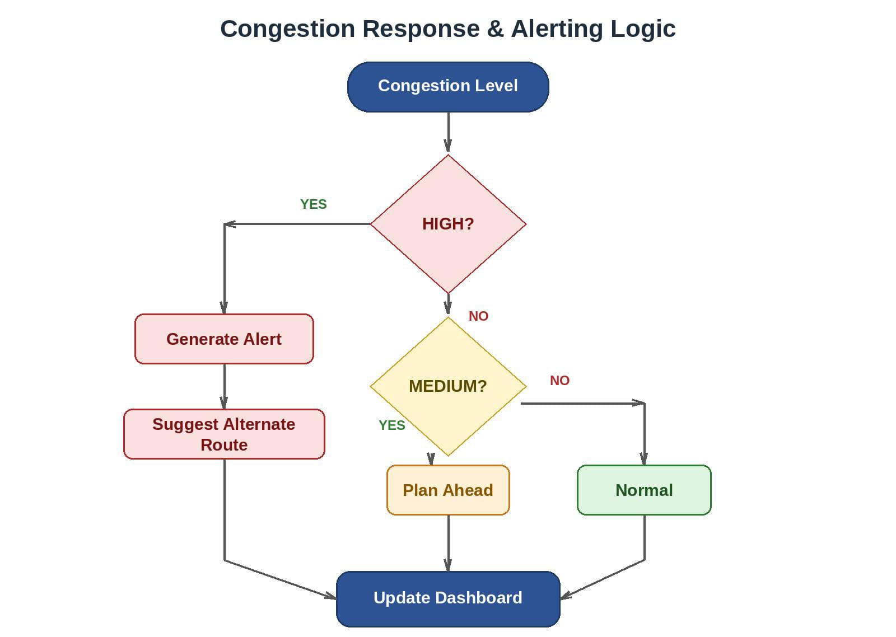

EXAMPLE:
If the congestion level is HIGH, the system generates an alert, recommends an alternate route, and displays a heavy congestion message. For MEDIUM congestion, the system advises the user to plan ahead. For LOW congestion, the system continues normal monitoring.

DATA FLOW:
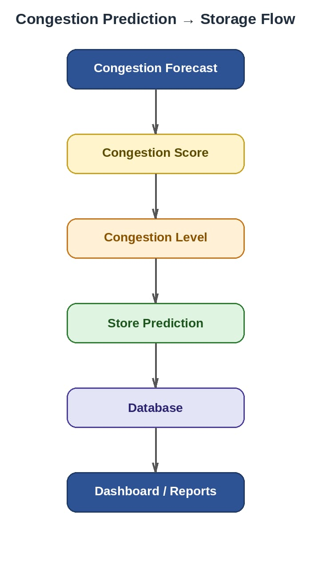

EXAMPLE:
If the system calculates a congestion score of 0.75 for Road R001 and classifies it as HIGH, the prediction result is stored in the database along with the road ID, prediction time, congestion level, and alert status.

DASHBOARD INTEGRATION:

PURPOSE:
The purpose of dashboard integration is to display the congestion forecasting results to users in an understandable and useful format. The dashboard receives the prediction results and displays the current congestion level, prediction details, and alerts.

What Information goes to the dashboard?
DATA | EXAMPLE
Road/Location | R001
Congestion Level | HIGH
Congestion Score | 0.75
Prediction Time | 08:30
Alert Status | ACTIVE
Message | Heavy Congestion Detected

DATA FLOW:
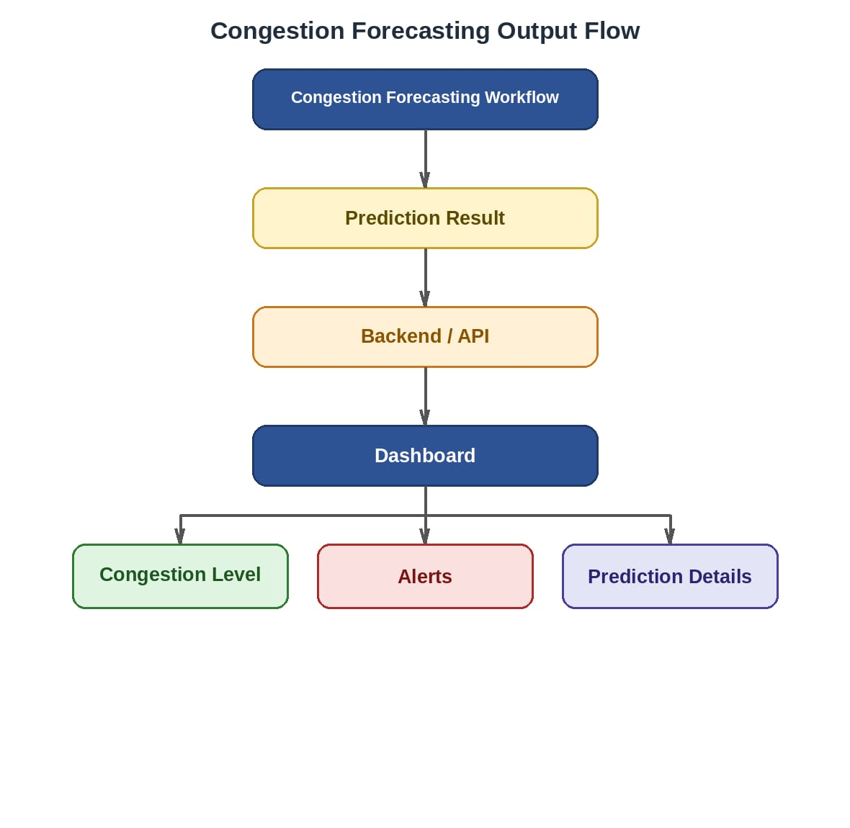

DASHBOARD DISPLAY:
- LOW → Dashboard shows normal traffic.
- MEDIUM → Dashboard shows moderate traffic.
- HIGH → Dashboard shows heavy congestion and an alert.
- The prediction time and road/location should also be displayed.

EXAMPLE:
If the forecasting workflow predicts HIGH congestion for Road R001 with a congestion score of 0.75, the result is sent through the backend/API to the dashboard. The dashboard displays the HIGH congestion status, prediction details, and an alert indicating heavy congestion.

FINAL WORKFLOW & REVIEW

FINAL OBJECTIVE:
The congestion Forecasting Workflow provides a complete process for receiving traffic data, preprocessing it, calculating and classifying congestion, generating appropriate alerts, storing prediction results, and integrating the results with traffic monitoring dashboard.

COMPLETE WORKFLOW:
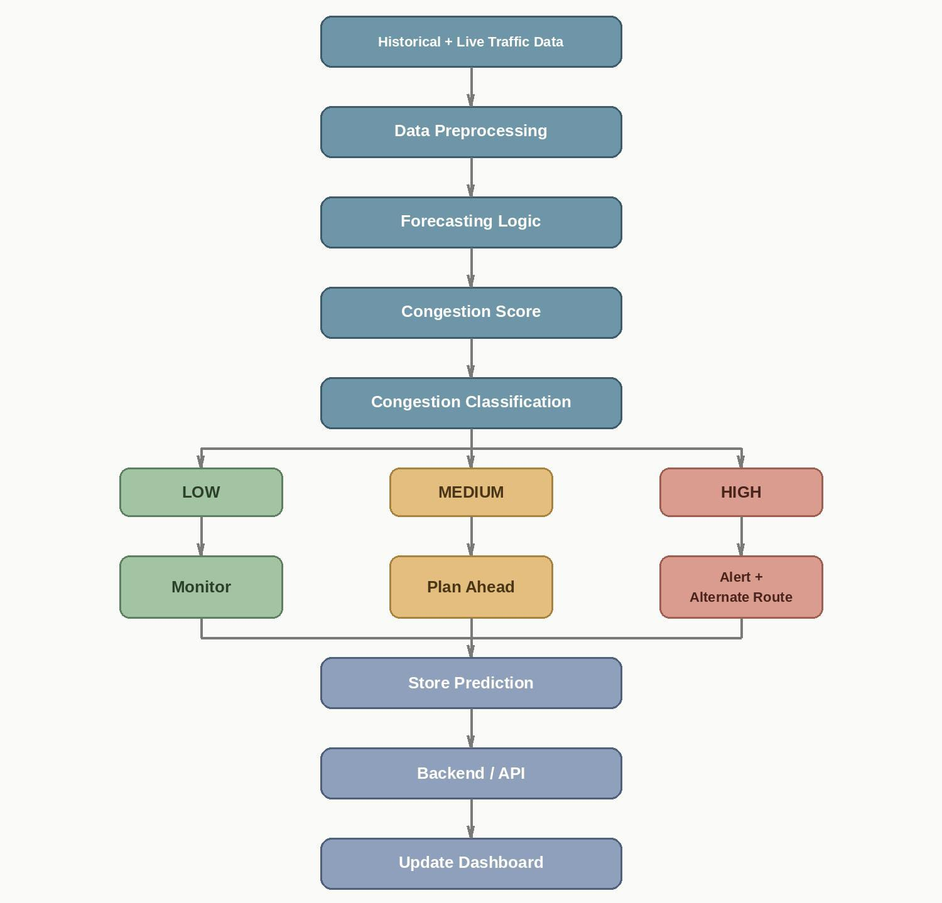

EXPECTED OUTCOME:
The Congestion Forecasting Workflow provides an end-to-end process for processing traffic data, generating congestion predictions, classifying congestion levels, triggering appropriate alerts, storing prediction results, and integrating the results with the traffic monitoring dashboard.

CONCLUSION:
The Congestion Forecasting Workflow has been documented from input data collection through forecasting, congestion classification, alert handling, database storage, and dashboard integration.

